ASSIGNMENT 4
- Deduce an expression for line neutral capacitance for a three phase overhead transmission line when the conductors are (i) symmetrically placed (ii) Asymmetrically placed but transposed.
- Derive the expression for the capacitance of a three phase double circuit hexagonal spacing configuration.
- Determine the capacitance and the charging current per km of a transposed double circuit three phase line operates at 220kv, dia of conductor is 2.5cm as shown in figure.

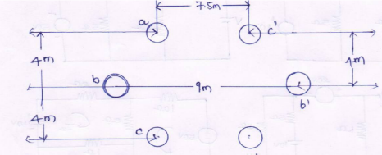
4. (a) Derive the expression for the capacitance of a single phase two wire line.
(b) A single phase transmission line has two parallel conductors 3m apart, radius of each
conductor being1cm. Calculate the capacitance of the line per km.
5 Calculate the capacitance (phase to neutral) of a 3-phase 100km long double cut line shown in figure with conductors of diameter 2.0 cm each, arranged at the corners of an hexogen with sides
measuring 2.1m.
